CS 305 Module Two Coding Assignment Template

Instructions
Replace the bracketed text with the relevant information in your own words. If you choose to include images or supporting materials, make certain to insert them in all the relevant locations in the document.

Run Dependency Check

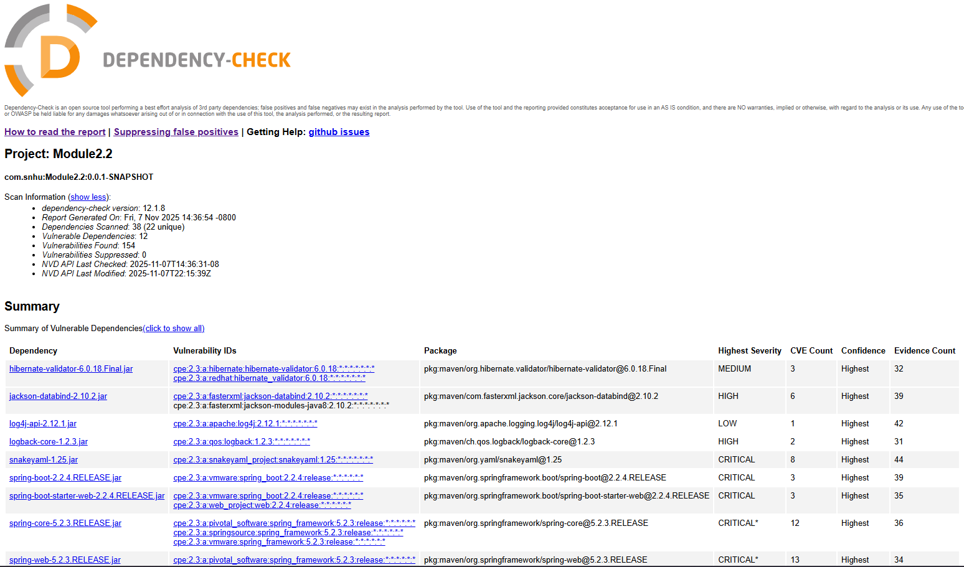

Document Results

Based on the dependency check, 12 dependencies were reported as vulnerable, totaling 154 vulnerabilities within the application. The 12 vulnerable dependencies are as follows:

Name | Description | CVE Codes | CVE Count | Evidence Count
hibernate-validator-6.0.18.Final.jar | Hibernate's Bean Validation (JSR-380) reference implementation. | CVE-2025-35036  CVE-2023-1932  CVE-2020-10693 | 3 | 32
jackson-databind-2.10.2.jar | General data-binding functionality for Jackson: works on core streaming API | CVE-2020-25649  CVE-2020-36518  CVE-2021-46877  CVE-2022-42003  CVE-2022-42004  CVE-2023-35116 | 6 | 39
log4j-api-2.12.1.jar | The Apache Log4j API | CVE-2020-9488 | 1 | 42
logback-core-1.2.3.jar | logback-core module | CVE-2023-6378  CVE-2021-42550 | 2 | 31
snakeyaml-1.25.jar | YAML 1.1 parser and emitter for Java | CVE-2022-1471  CVE-2017-18640  CVE-2022-25857  CVE-2022-38749  CVE-2022-38751  CVE-2022-38752  CVE-2022-41854  CVE-2022-38750 | 8 | 44
spring-boot-2.2.4.RELEASE.jar | Spring Boot | CVE-2023-20873  CVE-2022-27772  CVE-2023-20883 | 3 | 39
spring-boot-starter-web-2.2.4.RELEASE.jar | Starter for building web, including RESTful, applications using Spring MVC. Uses Tomcat as the default embedded container | CVE-2023-20873  CVE-2022-27772  CVE-2023-20883 | 3 | 35
spring-core-5.2.3.RELEASE.jar | Spring Core | CVE-2022-22965  CVE-2024-22259  CVE-2021-22118  CVE-2020-5421  CVE-2022-22950  CVE-2022-22971  CVE-2023-20861  CVE-2023-20863  CVE-2022-22968  CVE-2022-22970  CVE-2021-22060  CVE-2021-22096 | 12 | 36
spring-web-5.2.3.RELEASE.jar | Spring Web | CVE-2016-1000027  CVE-2022-22965  CVE-2024-22259  CVE-2021-22118  CVE-2020-5421  CVE-2022-22950  CVE-2022-22971  CVE-2023-20861  CVE-2023-20863  CVE-2022-22968  CVE-2022-22970  CVE-2021-22060  CVE-2021-22096 | 13 | 34
spring-webmvc-5.2.3.RELEASE.jar | Spring Web MVC | CVE-2022-22965  CVE-2024-22259  CVE-2021-22118  CVE-2020-5421  CVE-2022-22950  CVE-2022-22971  CVE-2023-20861  CVE-2023-20863  CVE-2022-22968  CVE-2022-22970  CVE-2021-22060  CVE-2021-22096 | 12 | 36
tomcat-embed-core-9.0.30.jar | Core Tomcat implementation | CVE-2020-1938  CVE-2024-50379  CVE-2024-52316  CVE-2024-56337  CVE-2025-24813  CVE-2025-31651  CVE-2025-49124  CVE-2020-11996  CVE-2020-13934  CVE-2020-13935  CVE-2020-17527  CVE-2021-25122  CVE-2021-41079  CVE-2022-29885  CVE-2022-42252  CVE-2023-44487  CVE-2023-46589  CVE-2024-24549  CVE-2024-34750  CVE-2024-38286  CVE-2025-48988  CVE-2025-48989  CVE-2025-49125  CVE-2025-52434  CVE-2025-52520  CVE-2025-53506  CVE-2025-46701  CVE-2020-9484  CVE-2021-25329  CVE-2021-30640  CVE-2025-55668  CVE-2024-23672  CVE-2022-34305  CVE-2023-41080  CVE-2021-24122  CVE-2021-33037  CVE-2023-42795  CVE-2023-45648  CVE-2024-21733  CVE-2024-54677  CVE-2019-17569  CVE-2020-1935  CVE-2020-13943  CVE-2023-28708  CVE-2021-43980 | 45 | 30
tomcat-embed-websocket-9.0.30.jar | Core Tomcat implementation | CVE-2020-1938  CVE-2024-50379  CVE-2024-52316  CVE-2024-56337  CVE-2025-24813  CVE-2025-31651  CVE-2025-49124  CVE-2020-8022  CVE-2020-11996  CVE-2020-13934  CVE-2020-13935  CVE-2020-17527  CVE-2021-25122  CVE-2021-41079  CVE-2022-29885  CVE-2022-42252  CVE-2023-44487  CVE-2023-46589  CVE-2024-24549  CVE-2024-34750  CVE-2024-38286  CVE-2025-48988  CVE-2025-48989  CVE-2025-49125  CVE-2025-52434  CVE-2025-52520  CVE-2025-53506  CVE-2025-46701  CVE-2020-9484  CVE-2021-25329  CVE-2021-30640  CVE-2025-55668  CVE-2024-23672  CVE-2022-34305  CVE-2023-41080  CVE-2021-24122  CVE-2021-33037  CVE-2023-42795  CVE-2023-45648  CVE-2024-21733  CVE-2024-54677  CVE-2019-17569  CVE-2020-1935  CVE-2020-13943  CVE-2023-28708  CVE-2021-43980 | 46 | 30

Analyze Results

Given the total number of vulnerabilities found in the application, these vulnerable dependencies need to be addressed to prevent hackers from exploiting and accessing the application. These vulnerabilities range from allowing hackers to hijack the user's session and run malicious code to pushing malicious data to the application. For instance, the hibernate-validator-6.0.18.Final.jar allows hackers to override filters on user input, thereby pushing malicious data to the server. The jackson-databind-2.10.2.jar dependency can cause a Java StackOverflowException, leading to a denial-of-service attack. Finally, the logback-core-1.2.3.jar dependency enabled hackers with the required permissions to alter configuration files in a way that allowed them to load and execute malicious code. The primary takeaway from these examples is that vulnerabilities in the dependencies provided hackers with the potential means to attack the application, potentially compromising the sensitive user data stored within it. To address the various vulnerability issues, updating these dependencies to their latest versions will resolve the vulnerabilities identified by the dependency checker. Performing this action is crucial to ensuring the application is developed properly and uses the latest versions of software that no longer contain these vulnerabilities. Updating these dependencies helps ensure that users of the application are not exposed to the risk of having their data compromised due to developer neglect. However, one of the main issues with updating these dependencies is the potential for the current code to fail due to changes in the dependencies, or for these dependencies to have been abandoned with no updates to address their known vulnerabilities. Even with these risks, it is in the best interest to work through them, such as fixing bugs caused by dependency updates or finding similar, actively developed dependencies. While this course of action will cost additional time and funds, it is worth the investment to ensure that user data is secure and that the application is coded to reduce the potential for attacks as much as possible. Another beneficial change to make going forward is to implement checks for the latest updates of the dependencies used within the application to avoid this issue from occurring again. In the end, the various vulnerabilities found through the dependency-check are problematic as they provide methods for hackers to attack the application and potentially steal sensitive data. However, these issues can be fixed by updating or replacing the vulnerable dependencies, and continuing to check for the latest versions of dependencies going forward to avoid this issue from occurring again.

